Graphics guidelines
Updated 11/1/07
Manning books have two types of graphics: screen captures and line art. Specifications for these graphics are set by our printer and must be followed closely by us in order for the graphics to print well and to look good in the published book. You may not be able to save your graphics files in the final desired formats and resolutions—Manning will do that for you during production—but you must follow the guidelines explained here when you create your graphics; that will make the pre-press preparation easier for us. These are the ideal formats and sizes for the two types of graphics.
- Screen captures—30 x 42 picas (or 5 x 7 inches), 300 dpi, TIF format, color
- Line art—30 x 42 picas (or 5 x 7 inches), EPS format, font size average 6-7 pts,
primary line width .5 pt
The graphics in the book will be printed in black and white only, but you should prepare and save your graphics in color. The graphics will appear in color in your manuscript for reviewers and later in the ebook as well. Production staff will convert them to grayscale for printing purposes.
You’ll embed your graphics in your Word files as you prepare your manuscript. You also need to submit all your graphics to production later as separate files, so be sure to save them separately as well.
Those are the basic facts about graphics. Now, let’s discuss them in more detail.
Screen captures—the mechanics
You can capture screen images using a package like Snagit or by pressing the Print Screen key and pasting the image into Paint or some other higher-end package like Adobe PhotoShop or Picture Publisher. Any of these will capture the screen at 96 dpi and save the image as a TIF. The printer specifications call for 300 dpi for screen shots, but you can submit them to production at 96 dpi; we resize the capture to fit the page, and we’ll change the dpi at that time. (We prefer to do this ourselves because resizing can lead to a loss of dpi and a blurry figure if not done properly.)
Screen captures—the aesthetics
In order for the screen to look good on the printed page, in black and white, you must consider two things: the size and the color combination used in the screen capture.
Sizing and cropping
The following figures show the same full-screen shot with variations in the OS screen resolution and one variation showing the screen cropped.
We captured figure 1 by pressing the Print Screen key and pasting into Paint. It was saved as a TIF, and resized in Photoshop, and the dpi was changed to 300. The OS screen resolution was 1280 x 1024; the figure wasn’t not cropped. As you can see, the details are hard to read.
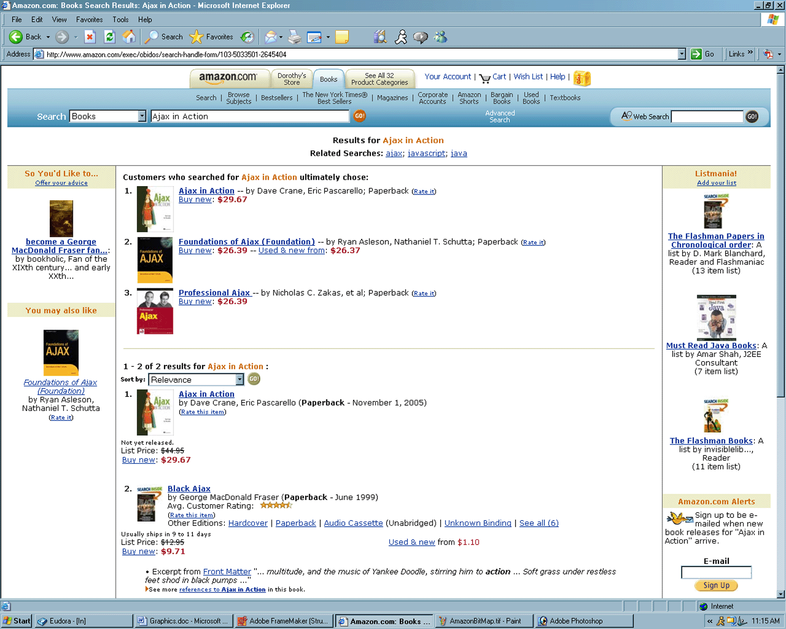
Figure 1 Screen captured using the Print Screen key and pasted into Paint, saved as a TIF, and resized in Photoshop, with the dpi changed to 300. The OS screen resolution was 1280 x 1024, and the figure wasn’t.
In figure 2, we used the same procedure to generate the graphics, but this screen shot was captured with the OS screen resolution set to 800 x 600. Less information is displayed, but what is displayed is much more legible.
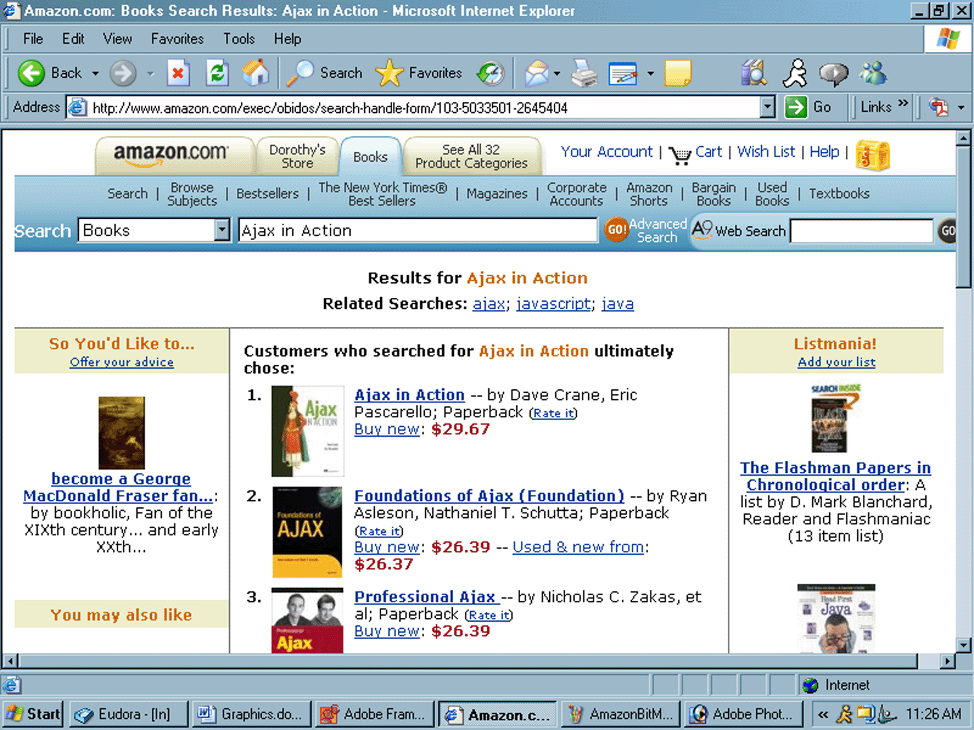
Figure 2 Screen captured using the same procedure as Figure 1, but with the OS screen resolution set to 800 x 600
Figure 3 shows how cropping can improve your screen shot. In this figure, the screen resolution is 1280 x 1024, as in figure 1, but some of the outside noise has been cropped. As a result, the information on the screen can be read more easily than in figure 1.
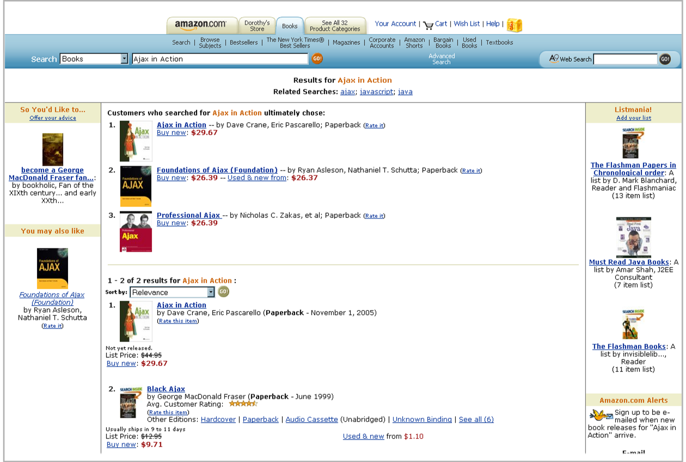
Figure 3 Screen captured as in figure 1, with a screen resolution of 1280 x 1024, but with some outside elements cropped.
Color
Because your book will be printed in black and white, you need to pay special attention to the colors that you choose to use in your screen shots. Your graphics will appear in color in the manuscript and in the ebook version, but on the printed page they will appear only in shades of gray. Please consider the shades of colors you select as well as the placement of colors next to one another within any one graphic:
- Don’t place two pale colors next to one another (like pink and yellow) or two dark colors next to one another (like red and blue), if you want to show contrast. Combining a dark color with a light color will have a much better effect in gray.
- When in doubt, translate your screen shots to grayscale as a test, and print them on a monochrome printer to see if the desired contrast was achieved. Or contact your Development Editor, who will be happy to send your screens to the Manning production staff to test them for you.
Line art—the mechanics
Many packages are available to create line art, and new ones are developed all the time. It’s impossible to keep this document updated with all of them. Manning typesetters use either Illustrator or CorelDraw. These are both high-end, expensive professional packages, and we realize that you may not have access to either of them. But if you do, please save your line drawings as EPS files.
Some of the more common packages our authors have access to and that we have worked with in the past include Draw (from Open Office), Visio, PowerPoint, and OmniGraffle. If you’re considering using anything else, please contact your Development Editor and send along a list of the possible Save As or Export formats for that package. The production staff will advise you which formats to send for a test so they can determine the best export format for that particular package. We prefer to get all the kinks worked out in the beginning, so send a graphics test as soon as you start working on your first chapter!
Please don’t create line art in a word processor. We can’t use these images. Your graphics must be saved as separate files so we can import them into our desktop publishing program. When our DTP opens your manuscript document, it goes through a filtering process, and embedded art won’t filter properly. Your graphics must be saved and submitted to us as separate files which are imported into the DTP.
The ultimate format that we’re striving for with line art is EPS. All of the more commonly used packages, with the exception of PowerPoint, will output EPS format. Some of the output isn’t as good as others, so we may ask you to save your line art in a different format for certain packages. Version variations add even more unpredictability. What works well with Visio 2003 and Illustrator 10, for example, may no longer work the same way with the next version of Visio or the next version of Illustrator. Pick a package, and send a test sooner rather than later. Table 1 lists the recommended formats for each of the acceptable packages.
Table 1 Recommended export formats
Software | Output format
Open Office “Draw” | EPS
Visio | VSD. Don’t save as EPS. The filter doesn’t work properly
PowerPoint | WMF or EMF
OmniGraffle* | PDF Vector (See below)
*OmniGraffle is a neat little Mac package that works well and produces nice effects. The problem is the compatibility between a PC and a MAC. If your figure uses Helvetica font, that will usually be fine; Helvetica has the same font name on PCs and Macs, and font substitution takes place easily. Other fonts may render as gibberish on a PC. We’ll be happy to give you tips on the best way to work in OmniGraffle to minimize problems later in production. For example, saving an OG file in PDF Vector format has been giving better results than saving in the EPS format. If you intend to use OmniGraffle to create your line art, please let your Development Editor know; they will ask a graphic designer to be in touch with you.
After you’ve saved the file in the requested export format as in table 1, save it again in its original native format. This is in case future changes to the graphic are requested during production. You’ll also have to save it a third time in a format that can be imported into your Word manuscript doc. A low-res GIF or JPG is fine for your manuscript. Just be sure to save the original native format.
Line art—the aesthetics
Here are some guidelines that will help create a neater piece of art.
- Font size for your text callouts inside the graphics should be 6-7 pts.
If you need a larger font for a label or caption, you can go up to 8-9 (2 pts. larger than the main text.) Don’t use larger font sizes in your graphics. They need to be in proportion to the fonts used in the body text of the final book page, which is usually 11 pts.
- Use Helvetica, Univers, or Ariel.
Pick one font, and use it in all your figures for an elegant and consistent look. (If you’re using OmniGraffle, please use only Helvetica.)
- The maximum illustration size should be 5 x 7 inches.
If the illustration doesn’t fit in the 5-inch width spec, you can change the orientation, making the figure longer rather than wider.
- Fill the icons as much as you can; don’t have a lot of white space inside an icon (box, circle, computer monitor, and so on). Make the icon only as big as it needs to be to hold the longest text of 6-7 pt type.
- Center the text both vertically and horizontally in the icon. Don’t let the text touch or overlap the outside lines.
- If you want to, you can use shadows to create depth.
- Use the same size and style of arrowhead in all illustrations, unless there is a reason to use different arrowheads in one drawing.
- Keep the line widths consistent, unless there’s a reason for some lines to be thicker than others, or dashed.
Most packages won’t give you a .5 pt line thickness, which is what we like to use in Manning books. If you can’t create lines with a .5 pt thickness, your typesetter will fix that during production.
- Don’t use fill patterns.
Visio has a fill pattern that looks like a checkerboard and another one that looks like latticework. These don’t translate well into grayscale graphics; you’ll only see a solid black box. If you need a fill, make it solid and a shade of gray.
Creating hedgehog diagrams
Hedgehog diagrams are used to annotate a line or snippet of code. A hedgehog diagram is basically a different kind of line drawing. It’s prepared using the same tools you use to create line art. Following are two sample hedgehog diagrams, with the elements used explained after the diagrams.

Hedgehog diagrams are a combination of the following elements:
- Code—Please set in 8 pt Courier font.
- Gray lines that point from explanations to sections of code—These should be drawn as 2 pt lines with the color set at 30% Black.
- Explanations of each code section—Explanations should be as brief as possible and set in either 8 pt Courier or 8 pt Helvetica/Univers/Ariel, whichever is most appropriate.
Filenames
Please name your files by chapter, then number: for example, 01_05.TIF or figure.1.5.TIF for the fifth figure in chapter 1. You can give your graphics proper names during development, such as “Increase in Productivity in 2007” or “Employment Chart” if that makes it easier for you to keep track of your graphics, but please be sure to number your graphics by chapter and figure number when you submit them to production. This numbering convention helps us know what chapter the figure belongs to and where in the chapter it should be placed. When your typesetter opens a zip file of 50, 60, or 100 graphics for your book, and they aren’t in any order, it slows down production because they must sort through all the graphics to determine which one belongs where. You can renumber them at the end, just before submitting your final manuscript to production.
Please also remember to refer to each figure in your text by figure number, so the typesetter will know where to place it. They will look for the reference: “See figure 5.1” or “As figure 5.1 shows…” and place the figure as close as possible to the reference in text.
Again, if you have any questions, please contact your Development Editor, who will put you in contact with the Production Manager or the Design Editor. We’ll be happy to look at your graphics at any time during the development process!

